Hall Ticket :2303A51257
Name : SANGU UDAY
Task 1 – Variable Naming Issues :
Before Using AI :
Code :
def f(a, b):
return a + b
print(f(10, 20))
After Using AI :
Code :
def add_numbers(first_number, second_number):
return first_number + second_number
print(add_numbers(10, 20))
RESULT :
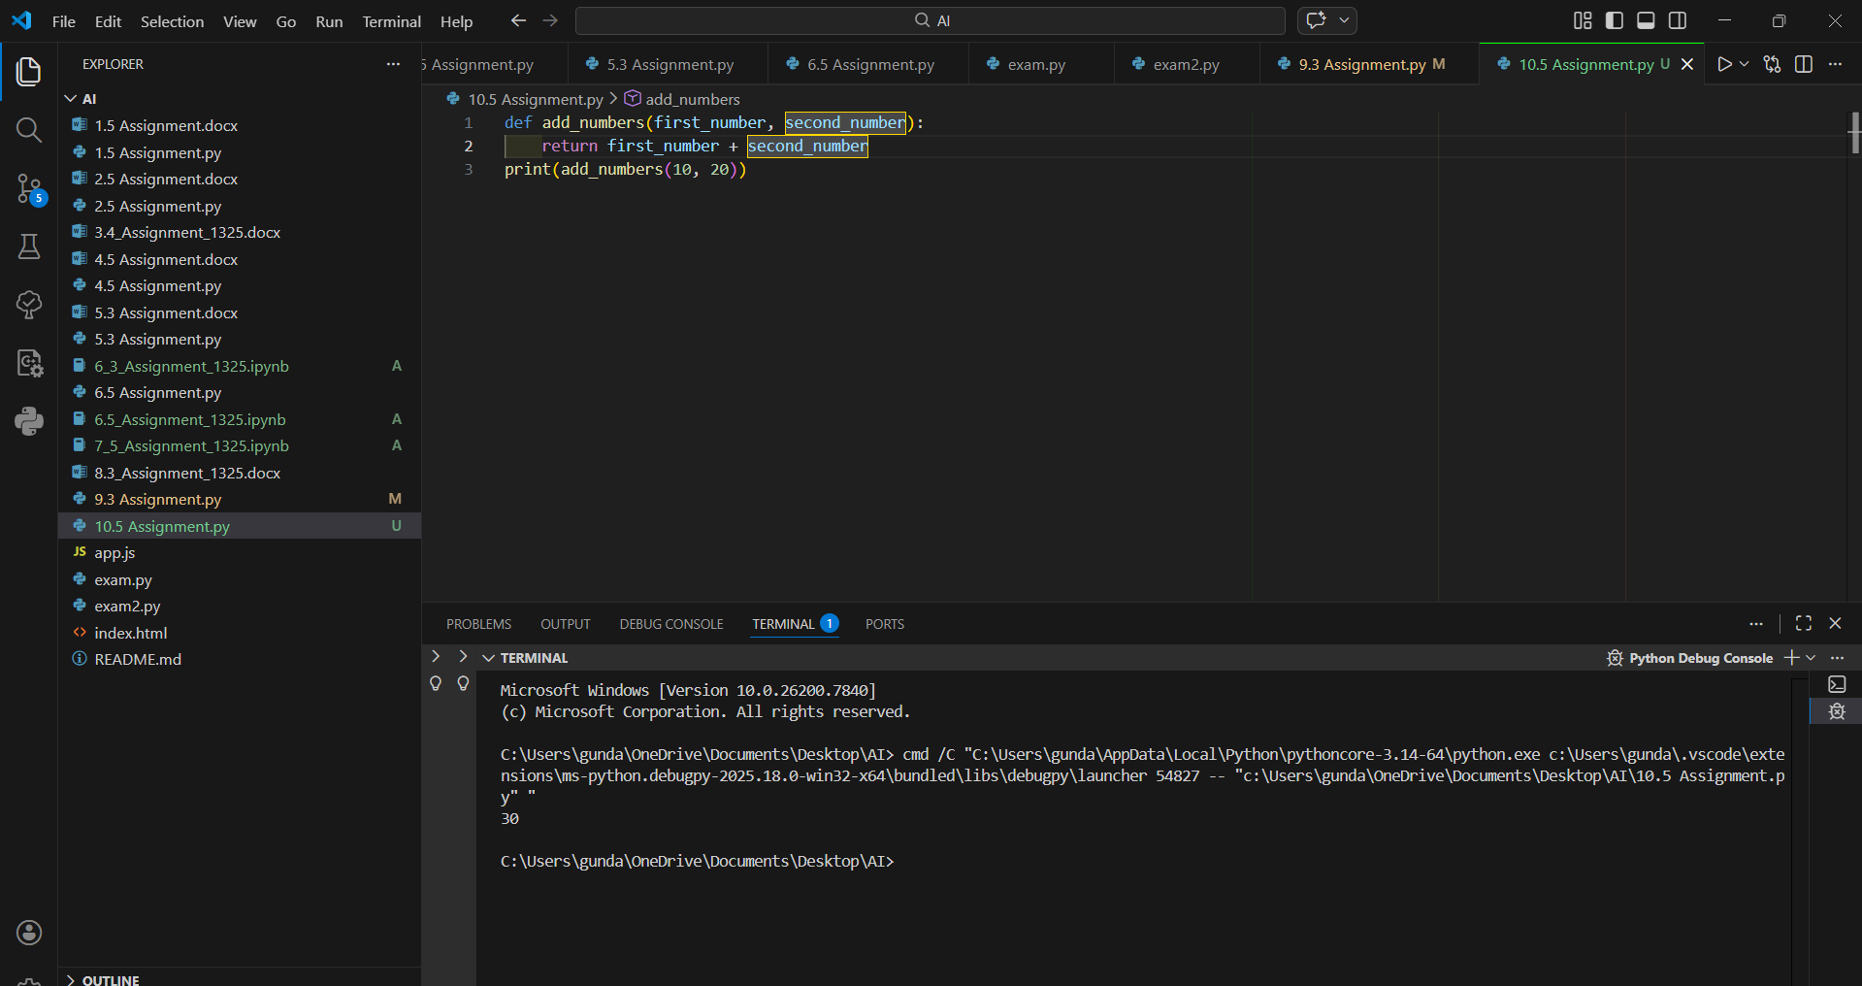
Explanation :
In the given code, the function name f and the parameters a and b are not descriptive. These names do not clearly explain what the function does or what type of values the variables represent. As a result, the code lacks readability and may confuse other developers who try to understand or maintain it.
To improve clarity, the function was renamed to add_numbers, which clearly indicates that the function performs an addition operation. The parameters were renamed to first_number and second_number to make their purpose more meaningful and self-explanatory.
By using descriptive names, the code becomes easier to read, understand, and maintain. This follows clean coding principles and improves overall code quality.
Task 2 – Missing Error Handling:
Before Using AI :
Code :
def divide(a, b):
return a / b
print(divide(10, 0))
After Using AI :
Code :
def divide_numbers(first_number, second_number):
try:
result = first_number / second_number
return result
except ZeroDivisionError:
return "Error: Division by zero is not allowed."
except TypeError:
return "Error: Please provide valid numeric inputs."
print(divide_numbers(10, 0))
Result :
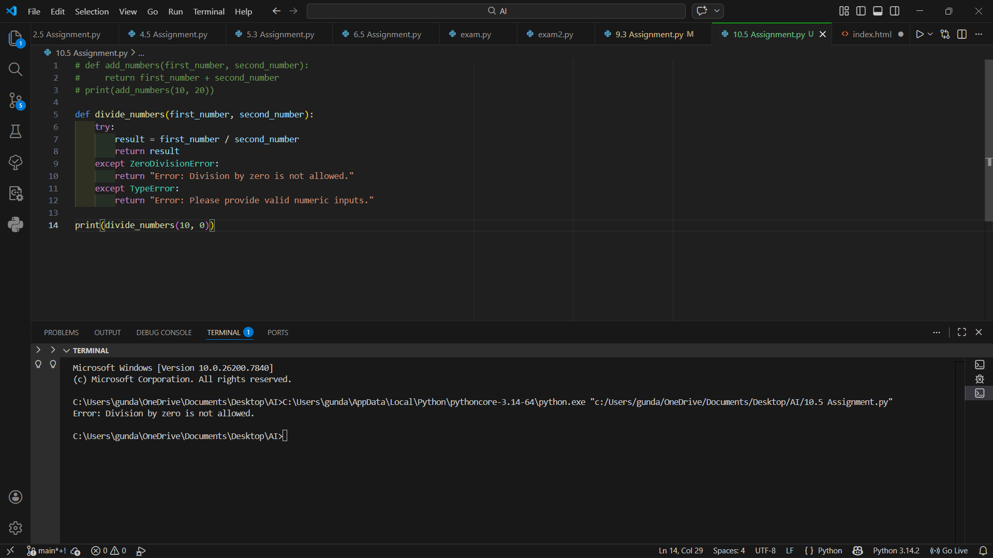
Explanation :
In the given code, the function divide(a, b) performs division without handling possible errors. When the function is called with b = 0, it causes a ZeroDivisionError, which crashes the program. The code does not include any mechanism to handle such runtime exceptions, making it unreliable.
To improve the code, exception handling was added using a try-except block. This ensures that if a division by zero occurs, the program does not crash. Instead, it displays a clear and user-friendly error message. Proper error handling makes the program more robust and prevents unexpected termination.
Task 3 – Student Marks Processing System:
Before Using AI :
Code :
marks=[78,85,90,66,88]
t=0
for i in marks:
t=t+i
a=t/len(marks)
if a>=90:
print("A")
elif a>=75:
print("B")
elif a>=60:
print("C")
else:
print("F")
After Using AI :
Code :
marks = [78, 85, 90, 66, 88]
try:
validate_marks(marks)
total, average = calculate_total_and_average(marks)
grade = determine_grade(average)

print(f"Total Marks: {total}")
print(f"Average Marks: {average:.2f}")
print(f"Grade: {grade}")
except (ValueError, TypeError) as error:
print(f"Error: {error}")

Result :
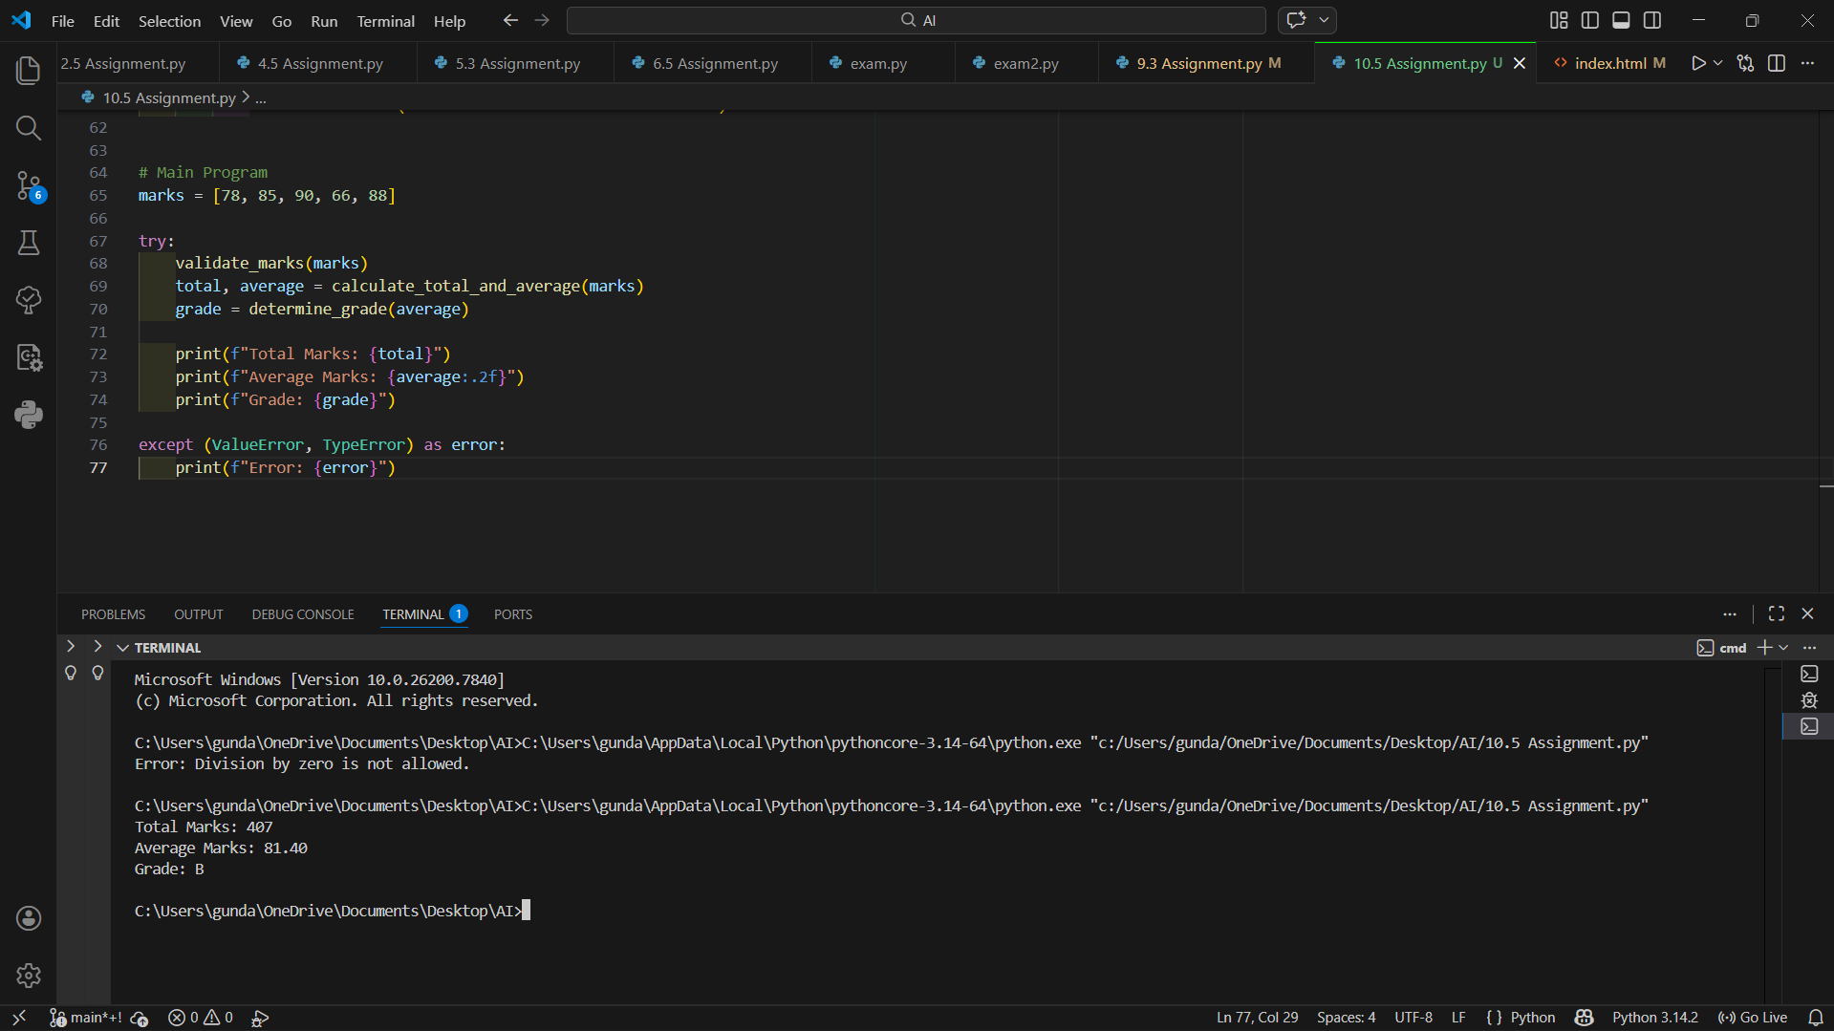
Explanation :
The given program calculates the total, average, and grade of a student. However, it has several issues such as poor readability, unclear variable names, lack of proper structure, no functions, no documentation, and no error handling. The variable names like t and a are not descriptive, and the logic is written in a single block, making it harder to maintain or reuse.
To improve the code, it was refactored according to PEP 8 standards. Meaningful variable names were introduced, the logic was divided into functions, comments were added for clarity, and basic input validation was implemented to ensure that the marks are valid numeric values between 0 and 100. Documentation (docstrings) was also added to explain the purpose of each function.
Task 4 – Adding Docstrings and Inline Comments:
Before Using AI :
Code :
def factorial(n):
result = 1
for i in range(1,n+1):
result *= i
return result
After Using AI :
Code :
def factorial(n):
"""

Calculate the factorial of a non-negative integer.
Parameters:
n (int): A non-negative integer whose factorial is to be calculated.
Returns:
int: The factorial of the given number.
Raises:
ValueError: If n is negative.
TypeError: If n is not an integer.
"""
# Validate input
if not isinstance(n, int):
raise TypeError("Input must be an integer.")
if n < 0:
raise ValueError("Factorial is not defined for negative numbers.")
result = 1 # Initialize result to 1 (factorial base value)
# Multiply result by each number from 1 to n
for i in range(1, n + 1):
result *= i
return result

Result :
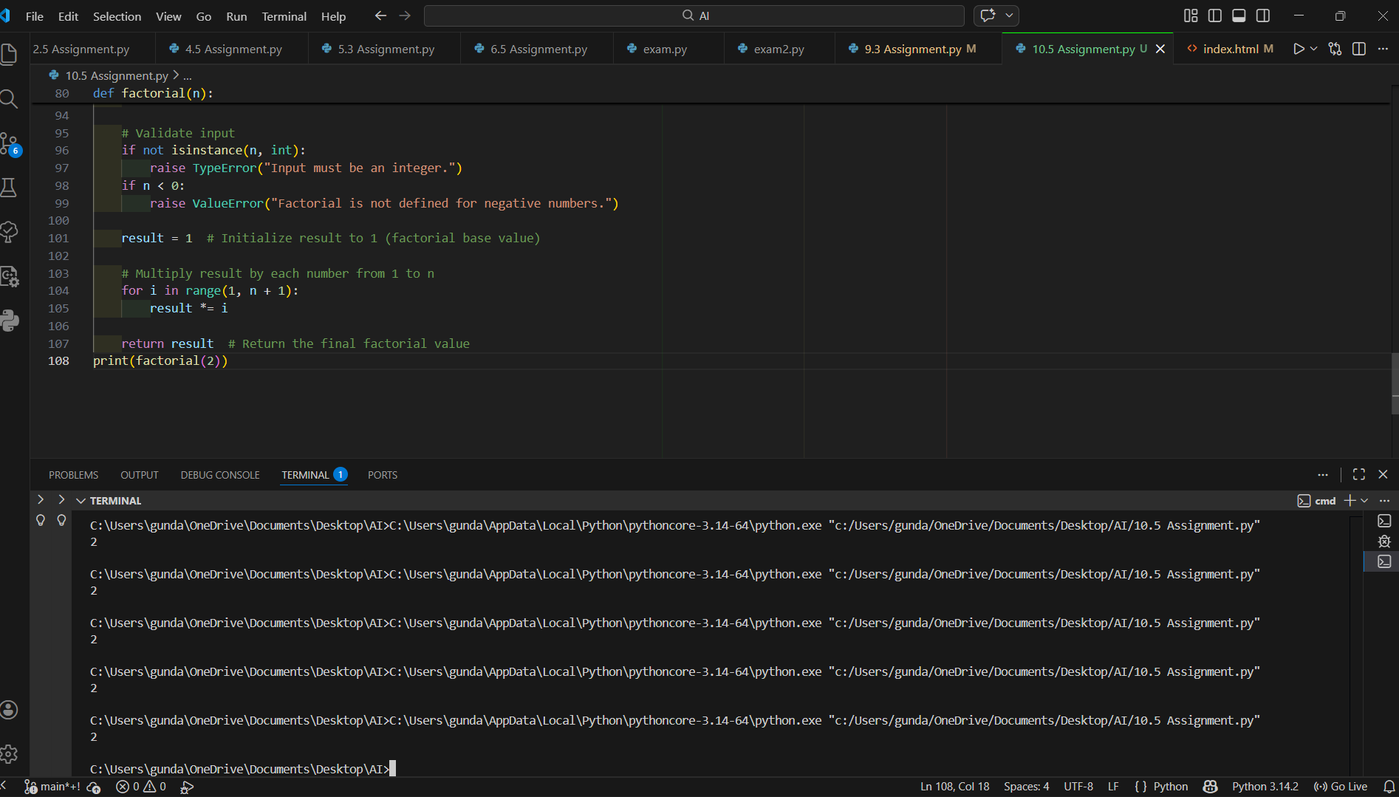
Explanation :
The given function calculates the factorial of a number but does not contain any documentation or comments. Without explanations, it may be difficult for other developers to quickly understand the purpose of the function, its parameters, or how it works internally.
To improve readability and maintainability, a proper docstring was added to describe the function’s purpose, parameters, return value, and possible errors. Inline comments were also included to explain the logic step by step.
Task 5 – Password Validation System (Enhanced):
Before Using AI :
Code :
pwd = input("Enter password: ")
if len(pwd) >= 8:
print("Strong")
else:
print("Weak")
After Using AI :
Code :
def validate_password(password):
"""
Validate a password based on multiple security rules.

Rules:
- Minimum length of 8 characters
- At least one uppercase letter
- At least one lowercase letter
- At least one digit
- At least one special character
Parameters:
password (str): The password entered by the user.
Returns:
str: Validation result message.
"""
# Check minimum length
if len(password) < 8:
return "Weak: Password must be at least 8 characters long."
# Flags to track required character types
has_uppercase = any(char.isupper() for char in password)
has_lowercase = any(char.islower() for char in password)
has_digit = any(char.isdigit() for char in password)
has_special_char = any(not char.isalnum() for char in password)
# Validate all conditions
if not has_uppercase:
return "Weak: Include at least one uppercase letter."
if not has_lowercase:
return "Weak: Include at least one lowercase letter."
if not has_digit:
return "Weak: Include at least one digit."
if not has_special_char:
return "Weak: Include at least one special character."
return "Strong: Password meets all security requirements."
# Main Program
user_password = input("Enter password: ")
result = validate_password(user_password)
print(result)
Result :
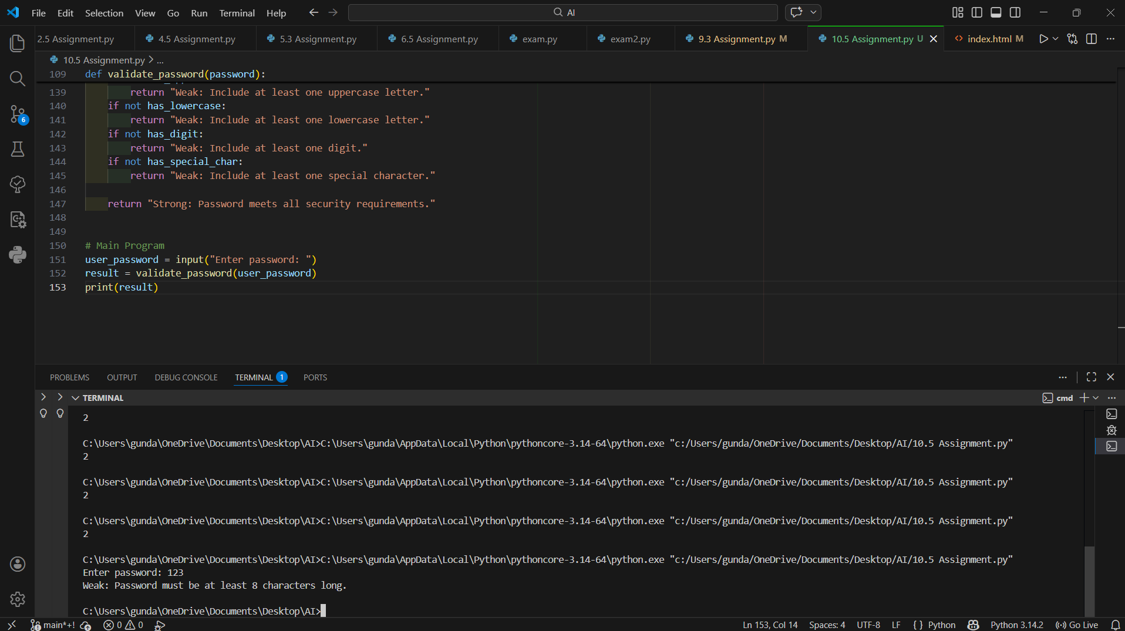
Explanation :
The original password validation program only checks whether the password has a minimum length of eight characters. While length is an important factor, it alone does not guarantee security. A password like "abcdefgh" meets the length requirement but is still weak because it lacks complexity. Additionally, the original code is written in a single block without functions, meaningful variable names, or documentation, making it less readable and harder to maintain.
The code is also refactored to improve structure and readability. A function named validate_password is introduced to separate the validation logic from user input. Meaningful variable names such as has_uppercase, has_digit, and has_special_char clearly describe their purpose. The inclusion of a docstring explains the function’s behavior, parameters, and rules, while inline comments make the logic easy to understand.
By following PEP 8 coding standards, the enhanced version maintains proper formatting, naming conventions, and structure, making the code more professional and easier to maintain.
Conclusion
The AI-enhanced password validation system is significantly more secure, structured, and maintainable than the original version. By introducing multiple validation rules, meaningful naming, proper documentation, and clean coding practices, the program now meets real-world security standards.
Overall, the improvements enhance code readability, reusability, and robustness, demonstrating how AI-assisted refactoring can greatly improve software quality and security

